Q. To create , Export and validate a Digital Certificate.
Aim: To write a code to create , Export and validate a Digital Certificate. Steps :
- Download and open ssl.
- Add its bin path in envirnment variable.
- Open command prompt.

Program:
C:\user\desktop>open reg-509 –day 365 –newkey rsa:204:keyout private-key pem-out certificate.pem
Enter PEM Pass : 123456 Country Name (2 letter code): IN
State or ProvinceName (Full Name):Mharashtra Locality Name[]: Mumbai
Organization Name : SIWS Organization Unit Name : iT Comman name :TMD
Email Address cs: vishwakarmakhushi442@gmail.com
C:\user\desktop>openssl pkcs12 –export –in certificate pem –inkey private-key.pem -out TMD.pfx
Enter Export Password:123456
Verifying – Enter Export Password:123456
>openssl pkcs12 –inTMD.pfx -clcerts –nokey – out public-key.pem Enter Import password:123456
Import the certificate. Result:

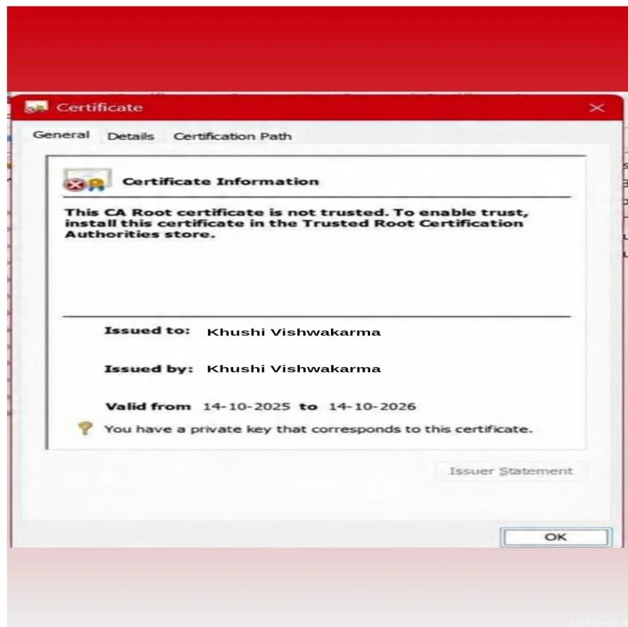
Conclusion: The above certificate is done successfully.

